You are welcome to join us for an

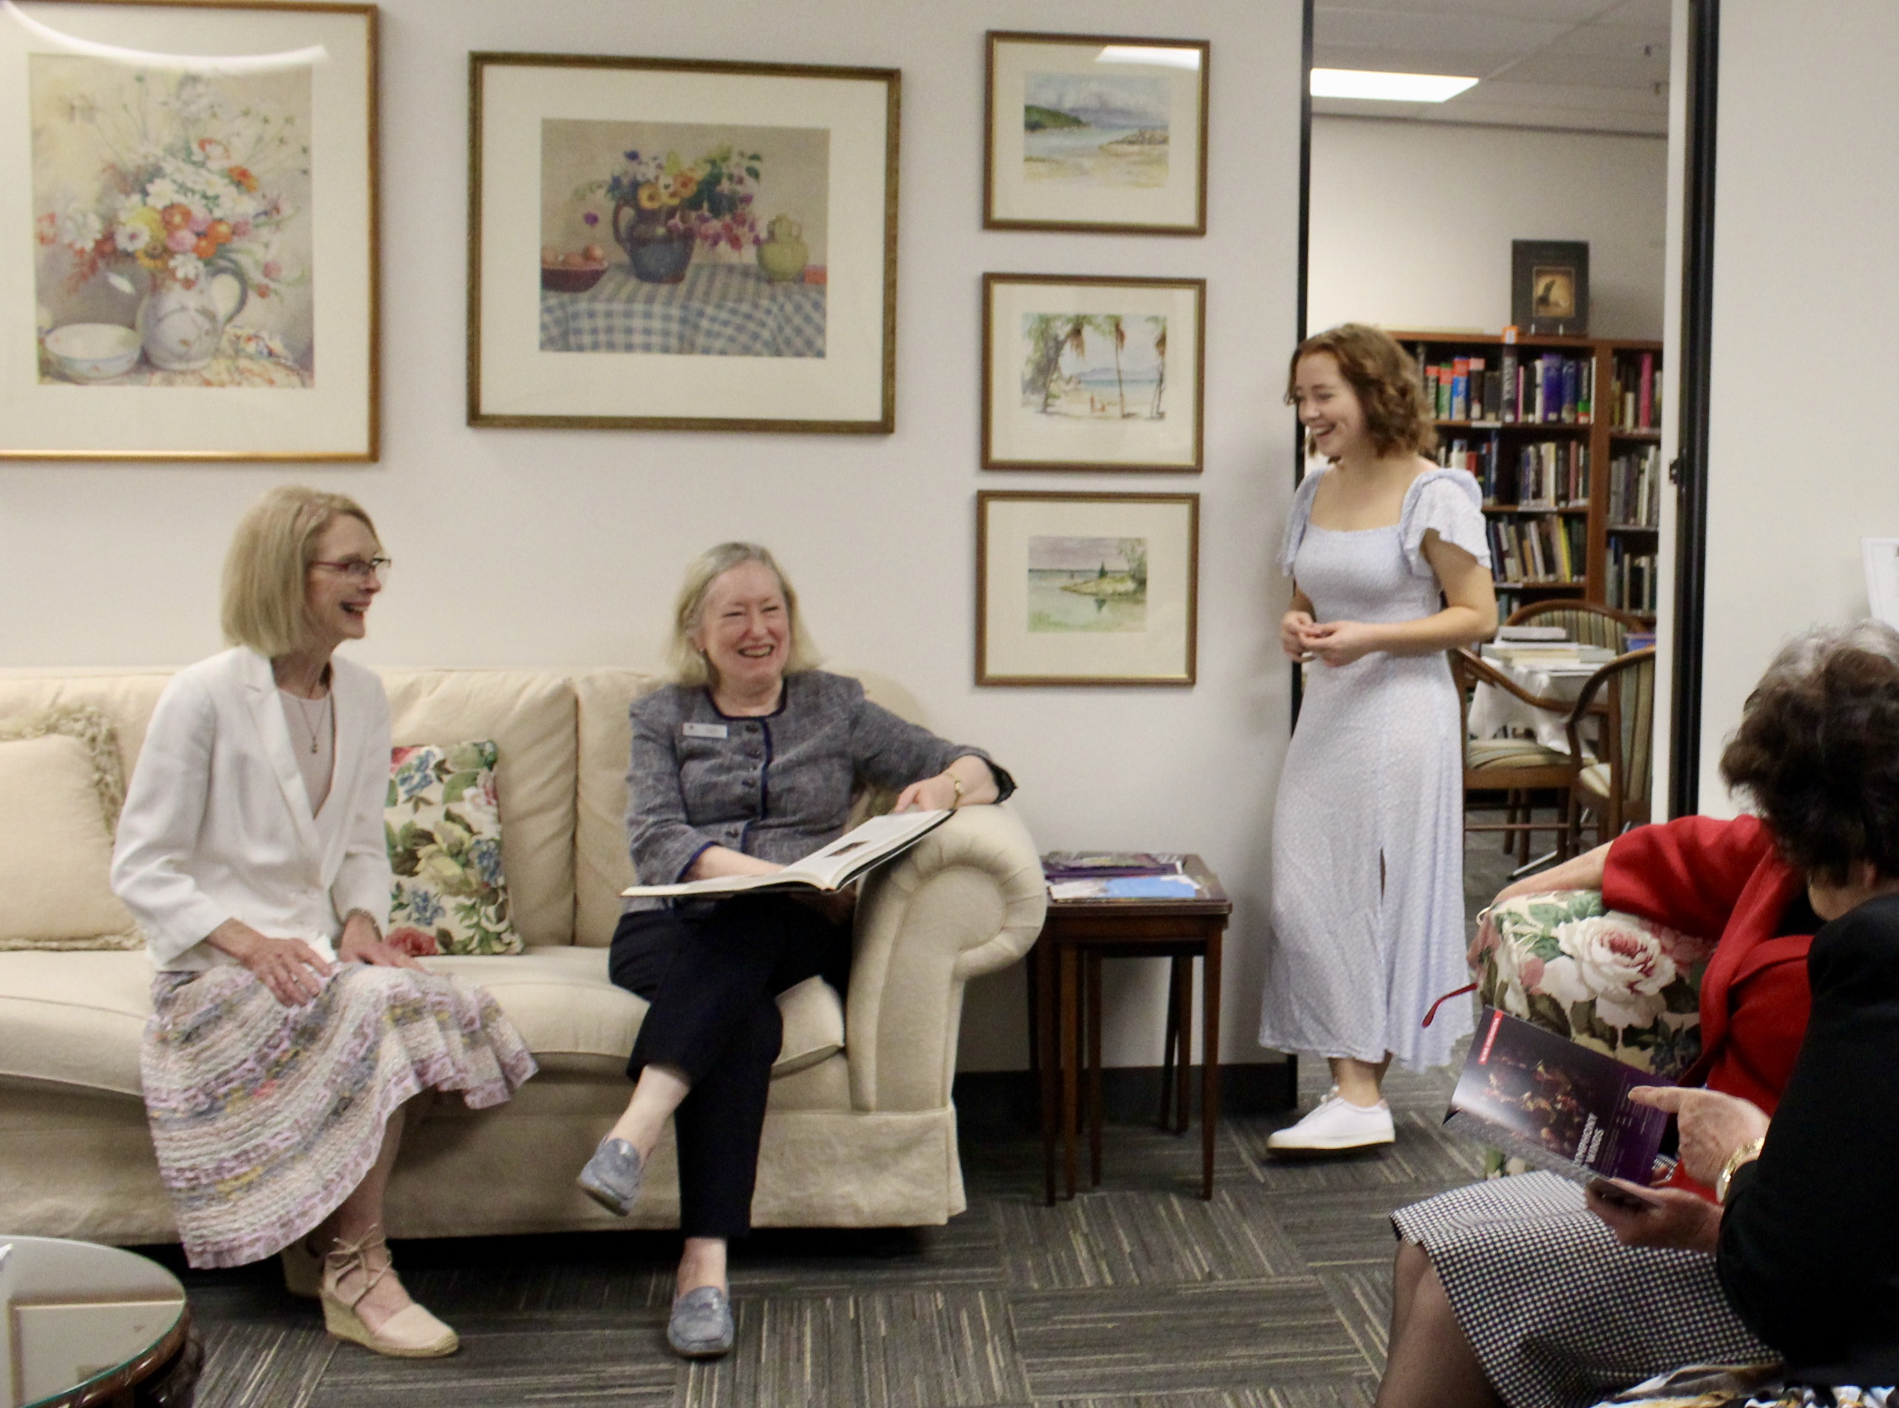
Open Club Evening at Lyceum Club Brisbane Inc.

Venue: Lyceum Club Brisbane
Level 4,
99 Creek Street Brisbane

Date: Friday 22 October 5:30pm

The Lyceum Club Brisbane Inc. is a women’s club which has been in Brisbane for over 102 years. It is a place where women gather in the CBD to share many common interests and to partake in life-long learning. Our Club is apolitical and non-sectarian.

Monthly Daytime Activities (Circles) include: Art, Books, Cinema, Mah-Jong, Music, Design & Handicraft, Poetry, Travel, Theatre, Writing, Singing, Walking and the Sunshine Coast Circle.
Bi-monthly Guest Speaker Forums and several Annual Events

Monthly Evening Activities : Le Cercle Francais, Evening Circle and Special Events.

The Open Club Evening will be a chance for you to interact with other members and guests and to find out more about our Club.

Refreshments will be provided

Website www.lyceumbrisbane.org.au/ Facebook: Lyceum Club Brisbane

RSVP: events@lyceumbrisbane.org.au
Name:……………………… Mobile:…………………...
Email………………………

