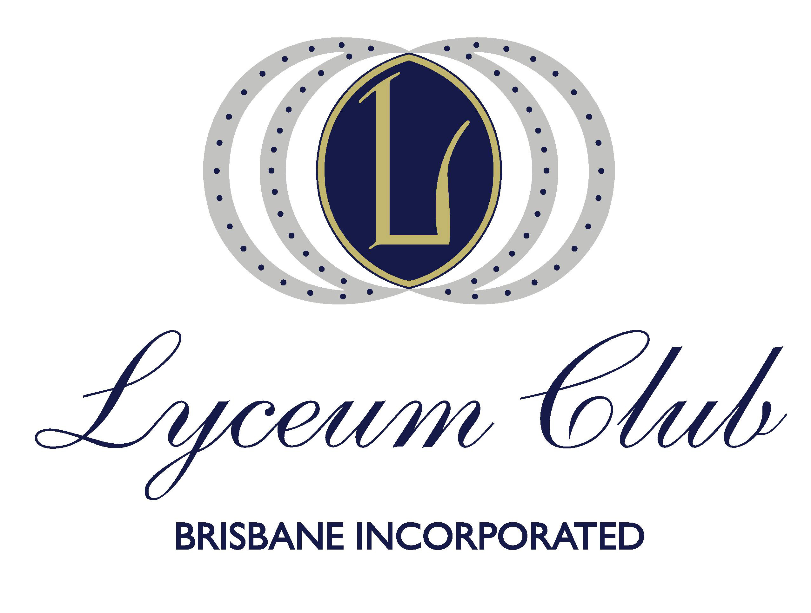

The President and the Management Committee
have much pleasure in inviting Members and their Guests to the

22nd Annual Lyceum Lecture
Tuesday 12 October 2021
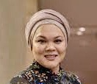
In recognition of the United Nations International Year of Peace and Trust, we are especially fortunate that Dr Norah Armath will be our Guest Lecturer.

Dr Nora Armath is an academic and humanitarian who has dedicated her career to human rights advocacy and building bridges of trust across community divides.

Venue: Tattersall’s Club Brisbane, Members' Dining Room
6.00pm for seating at 6:30 pm

Cost - $60.00 per person
This includes a glass of sparkling wine on arrival and a two course meal.
Our Club is the recipient of a Queensland Government Grant for Seniors. We thank the Honourable Craig Crawford MP and COTA (QLD). This grant has funded the cost of the Lyceum Lecture for Members and Guests

……………………………………………………………………………………
RSVP Monday 4 October.
Complete and send to events@lyceumbrisbane.org.au

Member’s Name: …………………………………………………………………..

Special dietary request……………………………………………………………..:.

Guest’s Name/s ……………………………………………………………………………….

Special dietary request: ……………………………………………………………………….
Payment - $55.00 per person Cheque – made payable to Lyceum Club Brisbane Direct Payment to: Lyceum Club Brisbane Inc. National Bank: BSB 084 034 Account no. 872021626 (Please include your name on the payment)

